Prime Retail Space
For Lease

338 N. Canon Drive, Beverly Hills
Second Floor
• Size: Approximately 5,302 rentable sq. ft.
• Rent: $3.00/SF/Month, NNN
• NNNs: $0.75/SF/Month
• Available: Immediately
• Parking Available
• Prime location on Canon Drive. Neighboring tenants include: Wolfgang’s Steakhouse, Spago, Umberto, Il Pastio, James Perse, Lucky Fish, La Scala, Porta Via, Maestros, and the Montage Hotel.

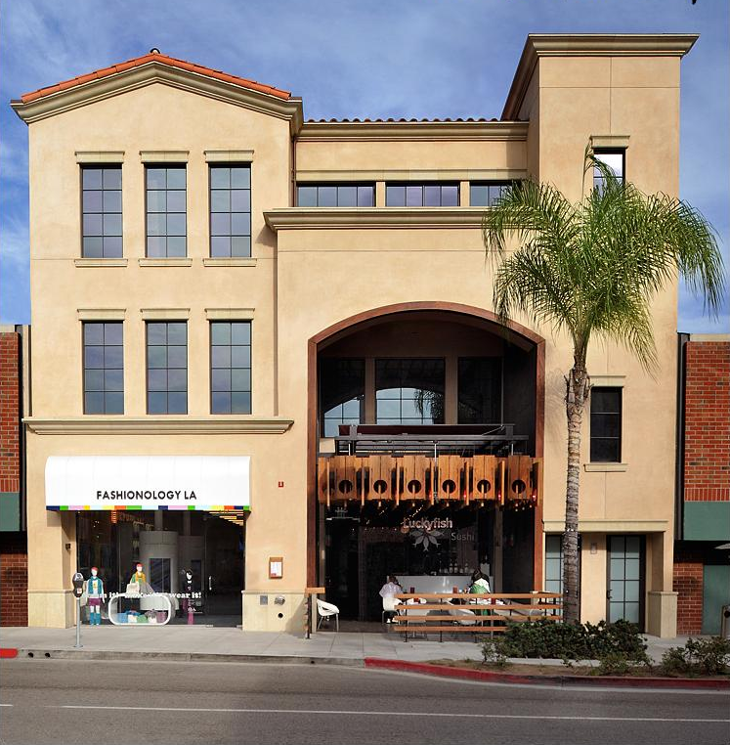
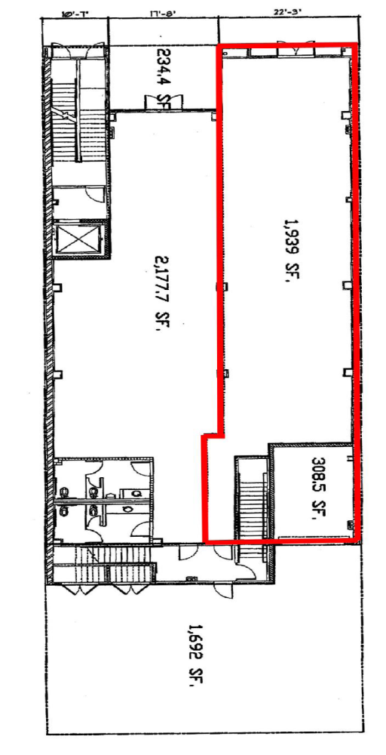





Noushin Ahobim
Realtor®

DRE # 01301933

Mobile: 310.863.4325
Direct Fax: 310.278.1938
E-mail: nahobim@aol.com

439 N. Canon Drive #PH Beverly Hills, CA 90210
Each office is independently Owned andOperated

